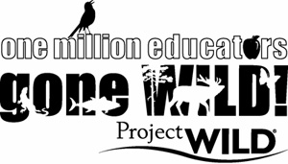



Project WILD Workshop Sample Agenda

9:00 am: Welcome
Icebreaker
Intro to Project WILD
9:30 am: Let’s get WILD!
- First Impressions, pg178
- Hazardous Links, Possible Solutions, pg 326
- Fashion a Fish, pg 98A
11:00pm- Field Investigations & Water Safari, pg 37A

12:00pm- Lunch

1:00 pm: Welcome back!
- Urban Nature Search, pg 70
- What’s For Dinner?, pg 96
- Migration Headache, pg 18A
- Oh, Deer!, pg 36

3:00 pm: Trek Through the Guide, Wrap-up & Evaluations

Thanks for Coming and Have a Great Day!

Kerry Wixted, Project WILD coordinator
Kerry.wixted@maryland.gov
410-260-8566

For alignments, resources and more info, please visit:
http://dnr.maryland.gov/wildlife/Pages/Education/ProjectWILD.aspx

