
Growing Up WILD Agenda

6:30 pm- Intro to Growing Up WILD & Grow-As-We Go icebreaker
7:00 pm-
Looking At Leaves- learn how to engage students to use their observation skills to explore leaves and plants

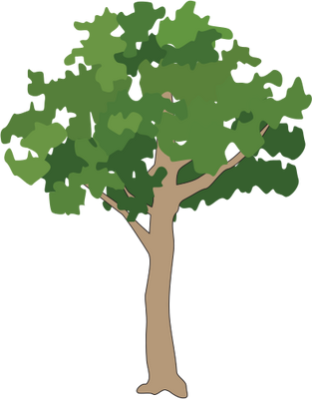
Spider Web Wonders- learn about spiders, how they differ from insects, and practice engineering a web

Who Lives in a Tree? - develop an awareness of trees and who calls them home through an interactive poem

9:10 pm- Skip Through the Guide
9:25 pm- Additional Resources & Wrap-Up

Thanks for coming!

Sarah Witcher, State Coordinator
sarah.witcher1@maryland.gov

Educator Resources & Alignments can be found here:
https://dnr.maryland.gov/wildlife/Pages/Education/GrowingUpWILD.aspx

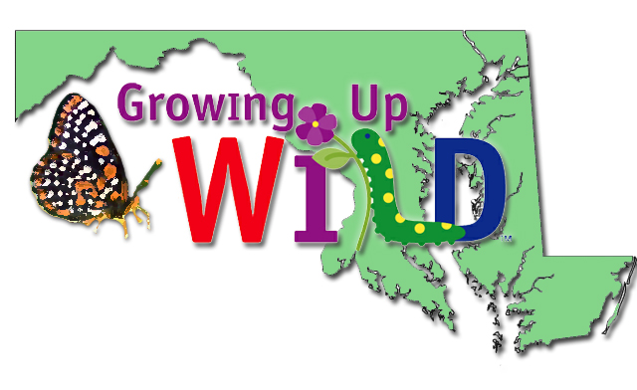

Wildlife & Heritage Educational Programs
For more information on these programs, please visit the wildlife education page here:
https://dnr.maryland.gov/wildlife/pages/education/home.aspx
 | Becoming an Outdoors Woman (BOW) Maryland women can learn about a wide variety of outdoor recreational opportunities in a casual, non-threatening environment by attending "Becoming an Outdoors-Woman" (BOW) workshops and Beyond BOW events. Contact Karina Stonesifer at karina.stonesifer@maryland.gov for details.
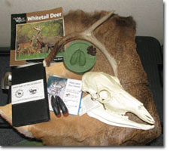 | Education Trunks & Kits: Bring the outside into your classroom with these unique hands-on, interdisciplinary teaching tools. Education Trunks are available free to educators in Maryland for a one to two-week period, depending on availability. Check out the following link for more details: dnr.maryland.gov/wildlife/Pages/Education/education_trunks.aspx
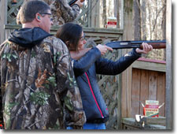 | Hunter Education Programs Firearms competency, hunter safety, ethical behavior and a keen understanding and appreciation of nature are essential elements of Maryland's Hunter Education Program. Contact Ricky Morris or Donnie Simmons at 410-643-8502. The Wildlife and Heritage Service offers many youth opportunities from Junior Hunt Days and more. Visit the website at: dnr.maryland.gov/wildlife/Pages/Education/youth.aspx
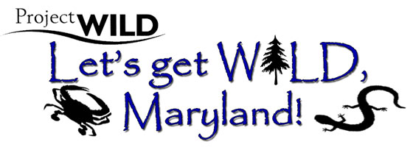 | Growing Up WILD & Project WILD These interdisciplinary environmental education programs emphasize the importance of wildlife. The programs are designed for educators who work with students of all types and are aligned with national and state standards. Contact Sarah Witcher at 410-260-8566 or Sarah.Witcher1@maryland.gov.
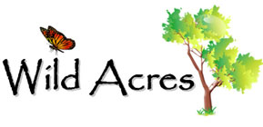 | Wild Acres The goal of the Wild Acres program is to create backyard habitats across the State that maximize wildlife benefits and highlight conservation stewardship. Contact Sarah Witcher at 410-260-8566 or Sarah.Witcher1@maryland.gov for details.

